
WEBSITE VISUAL DESIGN
For Greenfield Local Hub

13 March 2026
Greenfield Local Hub

Contents
Sitemap 1
Styles 2
Background 2
Fonts 2
Interactive 3
Buttons/Cards 3
Website Pages 3
Register/Login Page 3
Navigation bar 3
Home page 4
Privacy page 5
Products page 6
Producer Dashboard 7
Loyalty Points page 8

Sitemap

User Register / Login = This feature allows users to create an account or log in securely. During registration, users provide basic information such as name, email, password, and preferences.
The Home page is the main landing page of the Greenfield Local Hub (GLH) website or app. It introduces the hub and highlights locally produced food and drink available from member farmers and producers. The page showcases featured products, seasonal offers, and important updates from the hub. It also provides quick access to browse products, learn about local producers, and place orders for collection or delivery.
The Privacy page explains how customer and producer data is collected, stored, and protected when using the Greenfield Local Hub (GLH) digital solution. It outlines GLH’s policies regarding personal information, payment security, and how data is used for services such as account management, order processing, and delivery or collection arrangements. This page ensures transparency, helps users understand their data rights, and builds trust between customers, producers, and the hub.
Products
The Products page allows customers to browse locally produced food and drink available through Greenfield Local Hub. It shows product descriptions, prices, availability, and information about the producers. Customers can select items and add them to their order for collection or delivery.
Producer Dashboard
The Producer Dashboard is used by farmers and food producers who supply products to Greenfield Local Hub. It allows them to manage product listings, update stock levels, change product details, and view customer orders.
Loyalty Reward Page
The Loyalty Reward page provides information about the Greenfield Local Hub loyalty scheme. Customers can view their reward points, access special discounts or offers, and see how they can earn rewards by purchasing local products.

Styles

Background
- Body #F3F4F6
- Foreground #111827
- Hero background #DDEEE5

Fonts
- Font Family = “Segoe UI”
- Normal #000000
ef
- Heading #FF2F92

Interactive
- Normal

Buttons/Cards
- Slightly rounded
  - Radius = 10px

Website Pages
The email input field displays a highlighted border when focused to indicate the active field. Placeholder text guides the user on the required input format. Validation feedback is shown if the input does not match.

Register/Login Page
The password input field masks entered characters for security. When focused, the field border changes colour to indicate interaction. Error messages appear if the password does not meet security criteria.
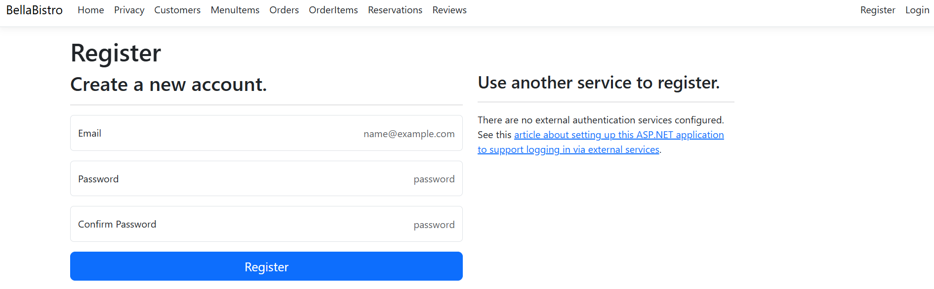
External service buttons are clearly separated from main form to distinguish alternative login methods. Each button includes recognizable branding colours to improve usability and user trust. Hover effects highlight availability without distracting from the primary login flow.
The confirm password field ensures both passwords match before submission. A visual warning is shown if the input differs to prevent user error.
The Register button uses a strong primary colour to stand out and encourage user action. When hovered, the button slightly increases in size and changes shade to provide visual feedback.
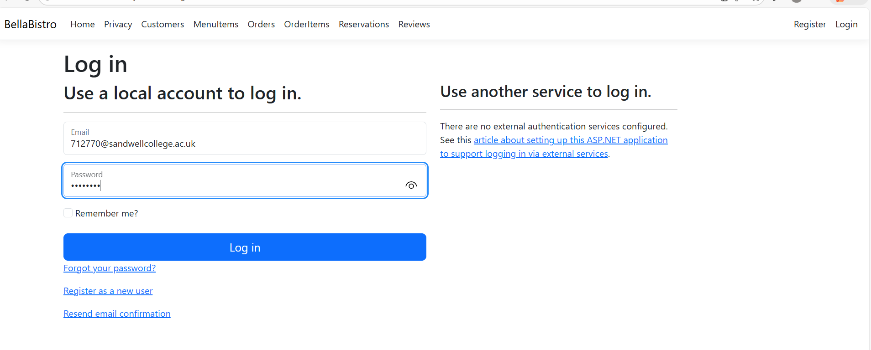
This section is reserved for the Greenfield Local Hub logo. The logo should be a square (equal width and height) and provided in Scalable Vector Graphics format to ensure scalable, high-quality display.
The forgot password link uses a secondary colour and underline on hover to indicate click-ability. This ensures accessibility while remaining visually subtle.
The login button is visually consistent with the register button to maintain design uniformity. A hover effect changes the button colour and adds a subtle shadow to indicate interactivity. The button provides instant feedback when clicked to confirm login submission.

Navigation bar

Home page
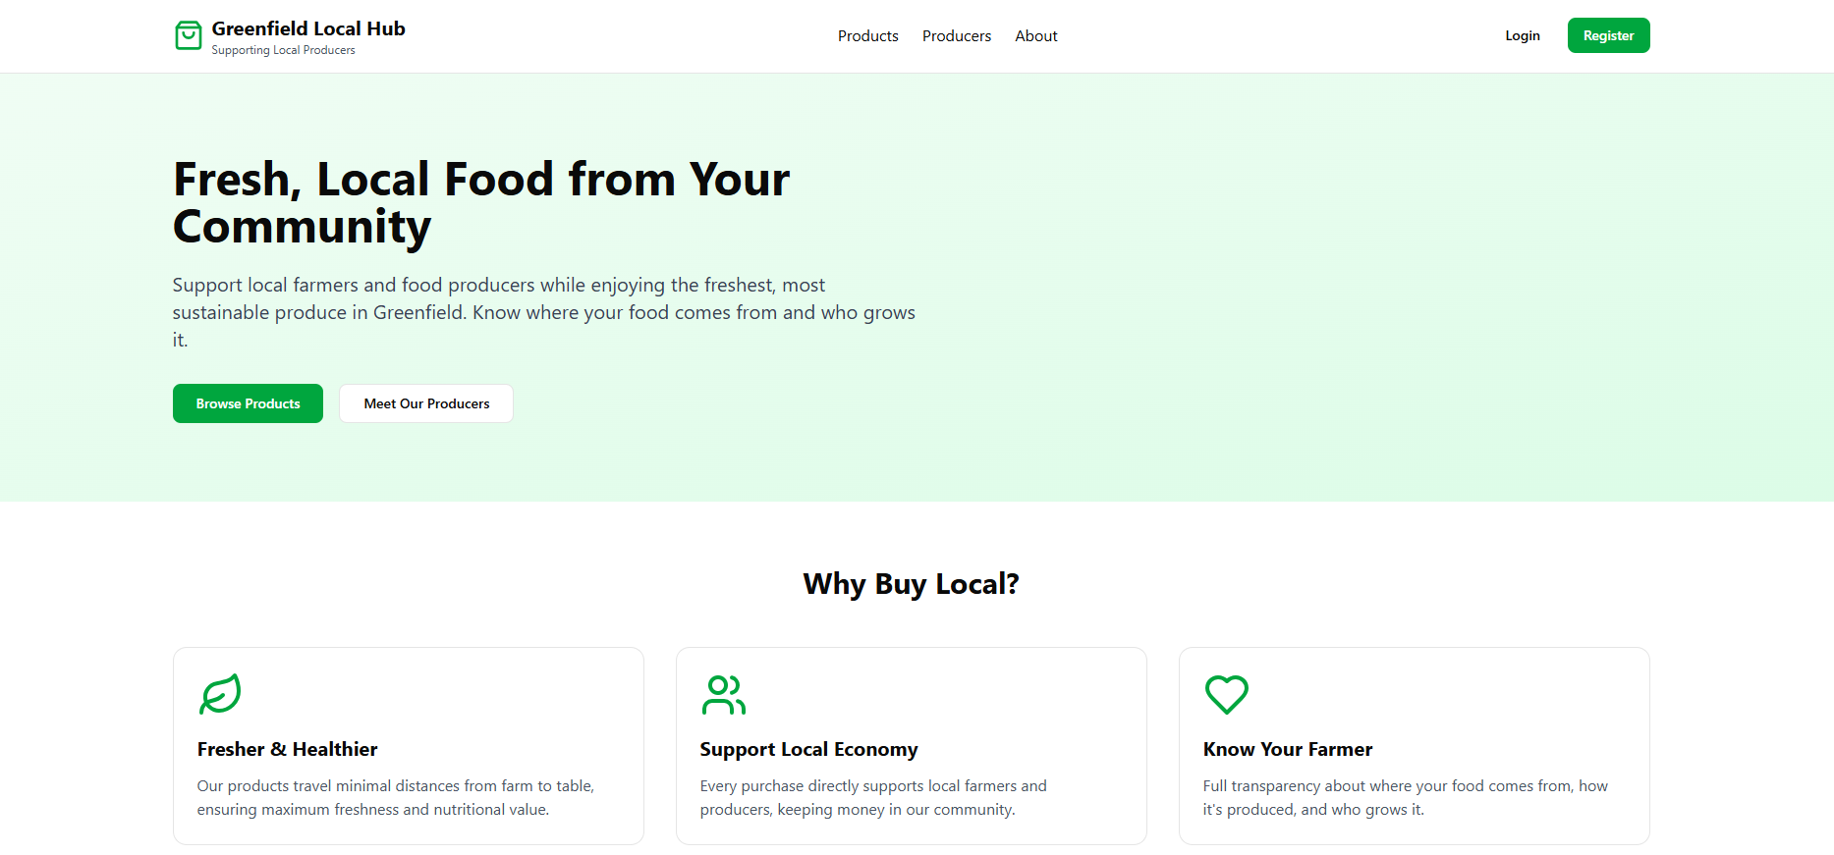
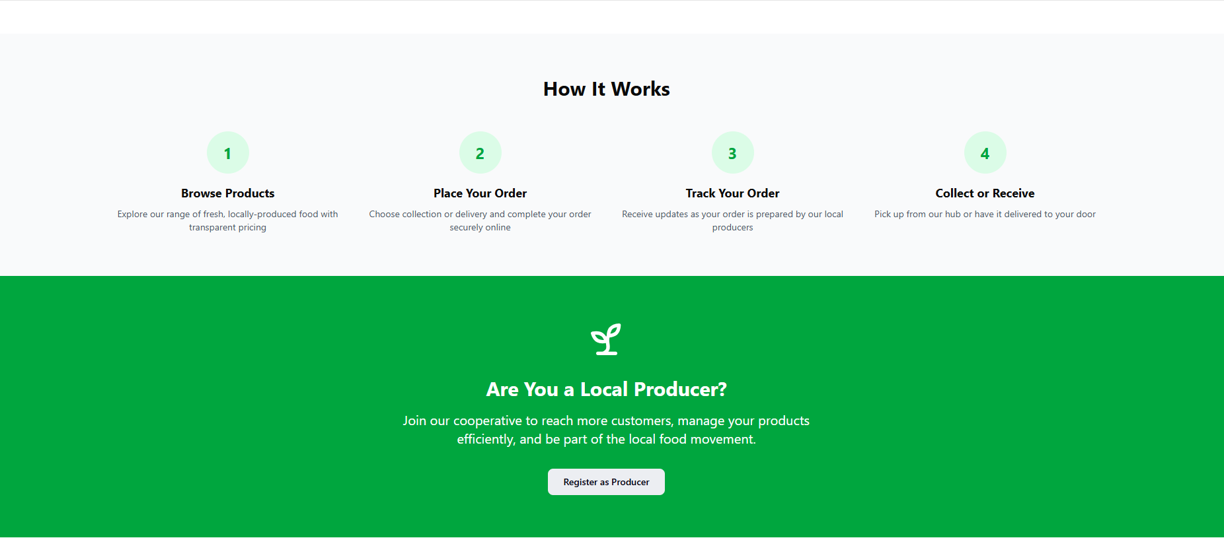
These design choices are important because they help create a professional, trustworthy, and user-friendly website for Greenfield Local Hub (GLH). A consistent colour scheme across the website helps maintain a cohesive and polished appearance, making the platform look reliable and easy to navigate. Using natural and earthy colours, such as greens and light neutrals, creates a welcoming atmosphere that reflects the theme of local farming and fresh produce while still maintaining a professional tone. This encourages users to stay on the website longer and explore the available products and producers.
The balance between background and foreground colours helps reduce eye strain, making the website comfortable to view for longer periods. Suitable colour contrast, such as green and white tones, improves readability and ensures that text and important elements are easy to see, which enhances the overall user experience.
Slightly rounded buttons contribute to a modern and organised layout, making navigation clear and intuitive. This allows users to move around the website easily, whether they are browsing products, learning about local producers, or placing an order.
Interactive images also add depth to the design and help highlight featured products or local producers, allowing users to quickly understand important information. Readable fonts help maintain a professional appearance while ensuring that text is clear and accessible for a wide range of users. Finally, clear and welcoming text on the homepage reassures visitors that they are in the right place to discover fresh, locally produced food from trusted farmers and producers in their community.

Privacy page
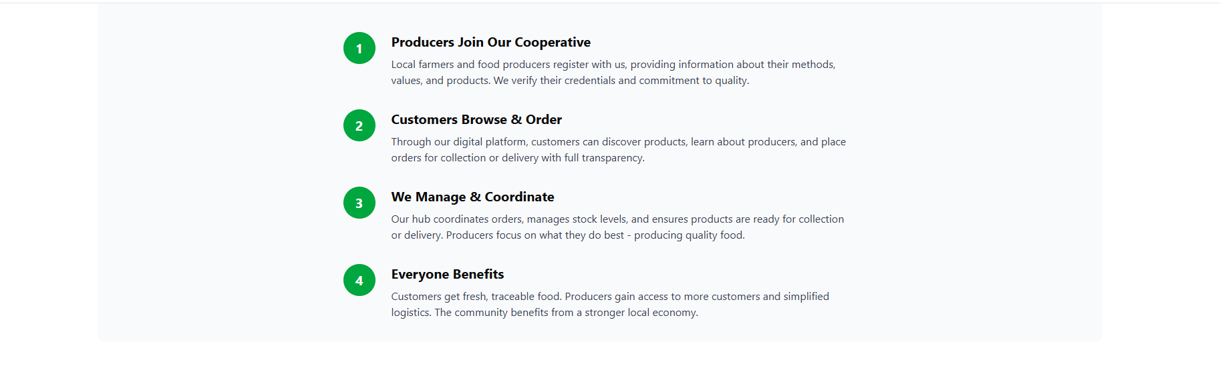
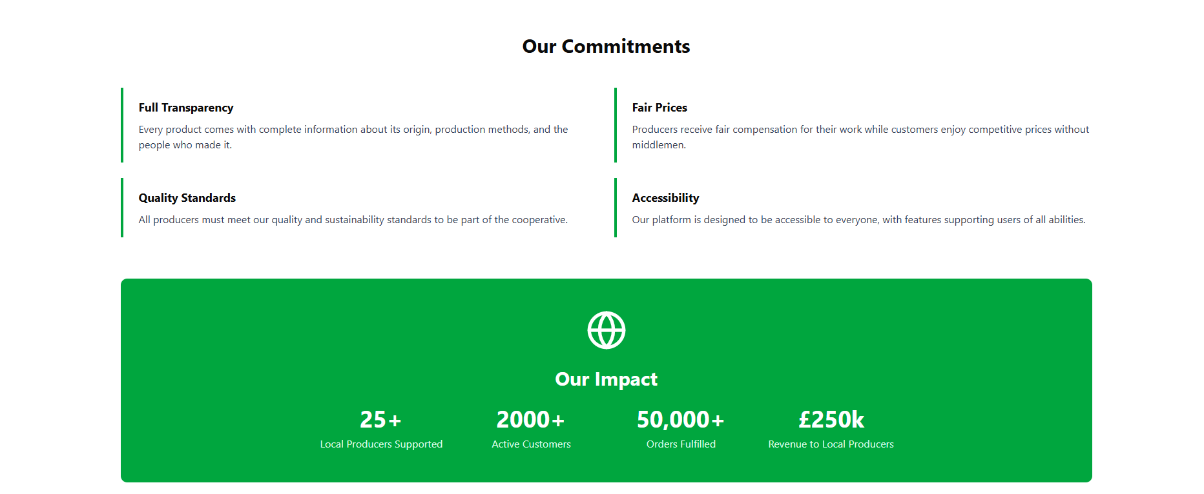
Different information sections are used to make the website clear, organised, and engaging for users. Positioning these sections near the top of the page ensures that important information is immediately visible, allowing users to quickly understand how the platform works and what it offers. This helps explain how producers join the cooperative, how customers browse and order products, and how Greenfield Local Hub manages orders and deliveries.
The website uses a green and white colour scheme, which reflects the natural and sustainable theme of local farming. Green is commonly associated with freshness, nature, and sustainability, making it appropriate for a platform that promotes locally produced food. The use of white backgrounds helps keep the layout clean and uncluttered, improving readability and allowing important information to stand out.
Clear explanations about transparency, fair pricing, and accessibility reassure users that the platform is reliable and that their information is handled responsibly. This helps build trust between customers, producers, and the cooperative.
The use of the Segoe UI for body text improves readability and maintains a modern, professional appearance. Typography and spacing are carefully applied to create a strong visual hierarchy, making the content easy to scan and understand. Important information stands out while supporting text remains clear and uncluttered.
Presenting information in structured sections improves usability by breaking content into manageable parts, reducing cognitive overload for users, and ensuring the page remains accessible and easy to navigate.

Products page
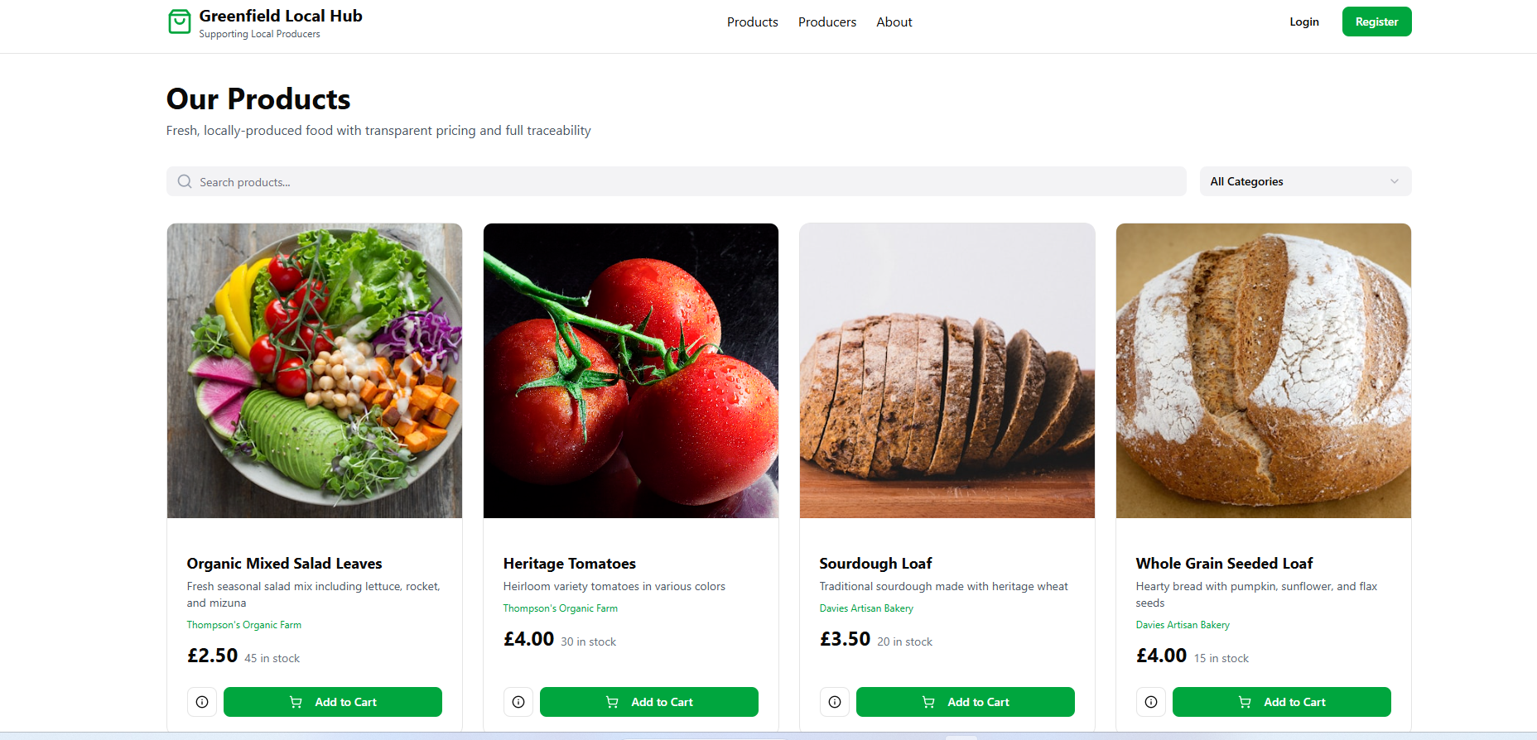
The products page is designed to allow customers to easily browse and view locally produced food and drink available through Greenfield Local Hub. Products are displayed in organised sections so users can quickly scan through available items and find what they are looking for. Each product includes key information such as the product name, price, and availability, ensuring pricing is transparent and customers can make informed purchasing decisions.
The website uses a green and white colour scheme, which reflects the natural and sustainable values of Greenfield Local Hub. Green is associated with freshness, farming, and environmental sustainability, which reinforces the platform’s focus on local produce. The white background keeps the layout clean and uncluttered, helping product images and information stand out clearly.
Clear product images help users quickly recognise items and make the page more visually engaging. Buttons such as “Add to Cart” or “View Product” are designed with rounded edges and strong colour contrast so they are easy to identify and interact with.
The use of a readable font such as Segoe UI ensures that product descriptions and prices are clear and accessible for a wide range of users. Spacing between products and sections also improves readability and creates a clear visual structure, making the page easy to navigate.
Overall, the design of the product page improves usability by allowing customers to quickly browse products, understand pricing and availability, and place orders efficiently. This supports Greenfield Local Hub’s goal of making it simple for customers to purchase fresh, locally produced food.

Producer Dashboard
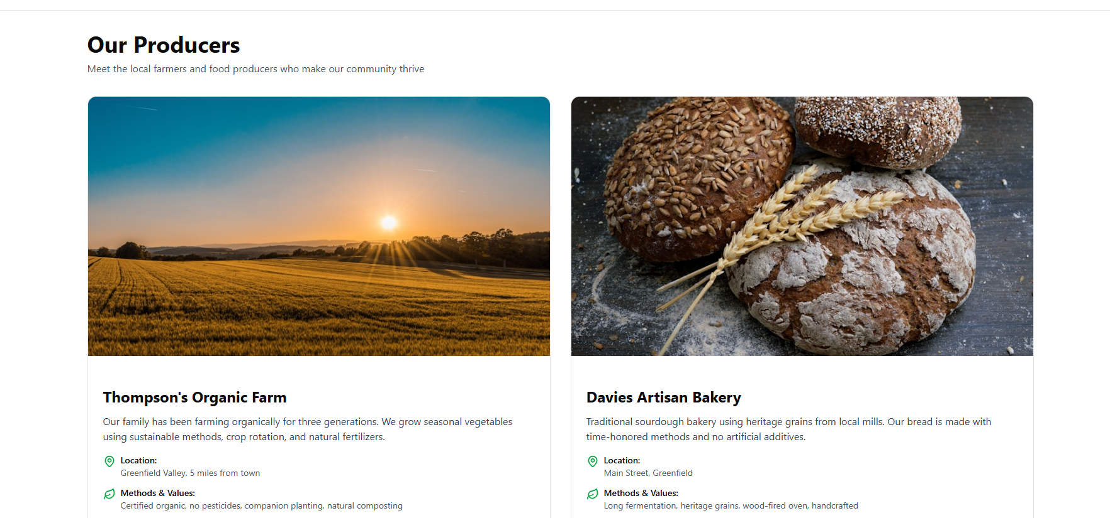
The Producer Dashboard is a dedicated area where local farmers and food producers can securely manage their product listings, stock levels, and orders. It displays important information such as the producer’s name, location, product details, and current inventory. This transparency helps producers maintain control over their offerings while keeping the cooperative’s product data accurate and up to date.
Presenting producer information clearly including location and contact details adds credibility and professionalism to the website. It aligns with industry standards by fostering trust between producers and customers, as buyers can easily verify where their food comes from. This level of transparency is essential for a cooperative focused on supporting local producers and promoting sustainable food systems.
The dashboard uses a clean, intuitive layout with a consistent colour scheme (greens and whites) that reflects the brand identity of Greenfield Local Hub. The use of readable fonts and clear visual hierarchy ensures producers can efficiently navigate and update their information without confusion or delay.
By providing producers with a robust, easy-to-use management tool, the website meets professional expectations for business platforms. It streamlines stock control and order processing, reduces errors, and enhances communication between the hub and its producers. These features demonstrate the website’s commitment to quality, efficiency, and support for the local farming community, reinforcing its reputation as an industry-standard digital solution.

Loyalty Points page
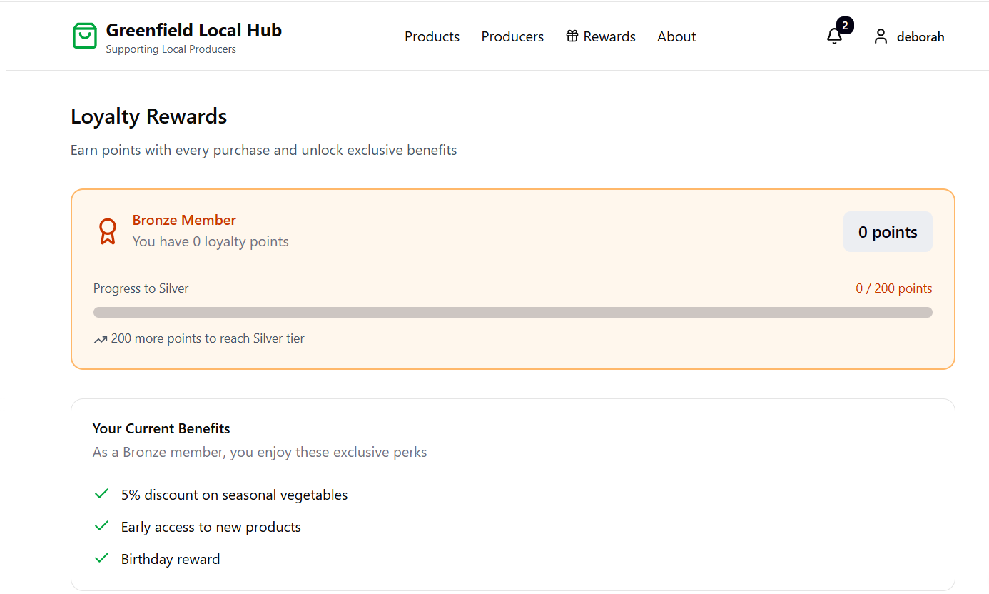
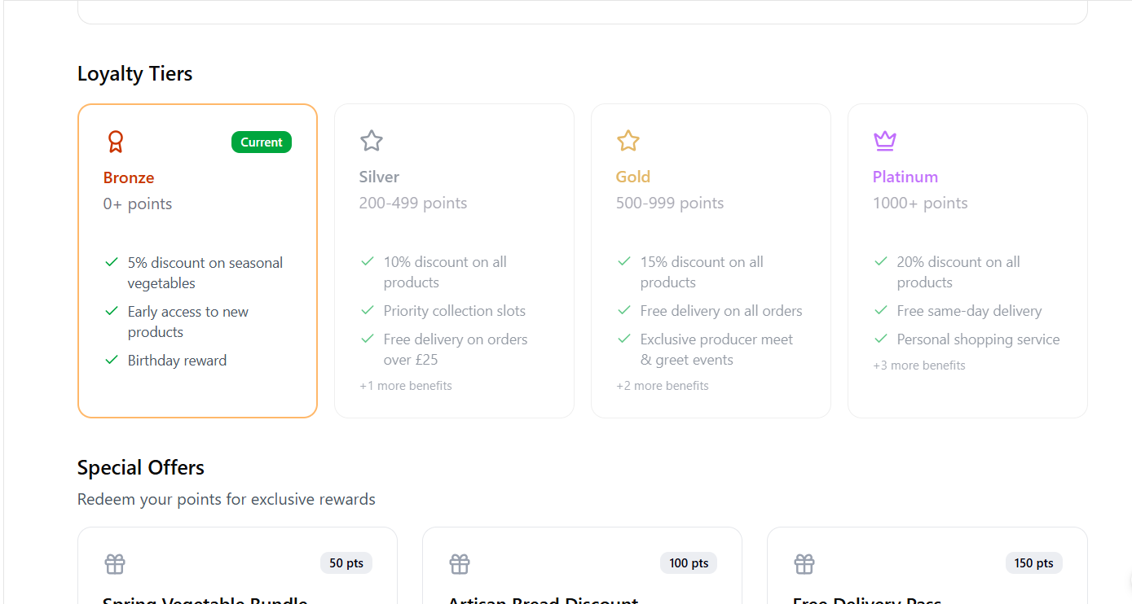
The Loyalty Rewards page provides customers with a clear overview of their membership status, reward points, and available benefits within the Greenfield Local Hub platform. It displays the user’s current loyalty tier, the number of points they have accumulated, and their progress toward the next membership level. This allows customers to easily track their engagement with the platform and understand how their purchases contribute to unlocking additional rewards.
The system uses a tiered structure consisting of Bronze, Silver, Gold, and Platinum levels, each offering increasing benefits such as discounts, priority collection slots, free delivery, and exclusive offers. By clearly presenting these tiers and their requirements, the platform motivates customers to continue purchasing from local producers in order to gain higher rewards. This approach aligns with common industry practices used in modern e-commerce platforms to improve customer retention and encourage repeat purchases.
The page uses a visually structured layout with clearly defined sections for membership status, benefits, loyalty tiers, and redeemable offers. A warm, earthy colour palette is used to reflect the brand identity of Greenfield Local Hub. Bronze, silver, gold, and purple tones visually represent each loyalty tier, while neutral background colours help maintain readability and balance. Progress bars and point counters provide clear visual indicators that allow users to quickly understand their current status and the points needed to reach the next level.
Typography is kept clean and consistent across the page, ensuring information such as benefits, point values, and offers can be read easily. Icons and check marks are used to highlight available perks, improving visual hierarchy and making the content more user-friendly. These design elements ensure the loyalty programme is both accessible and engaging for users.
By integrating a well-structured loyalty system, the platform encourages continued engagement while rewarding customers for supporting local producers. This feature enhances the overall user experience, strengthens customer loyalty, and supports the cooperative’s goal of building a sustainable community marketplace. The design and functionality demonstrate professional standards expected from modern digital retail platforms.

